Introduction
Coffee machine

Product specifications

Names of parts

1. Holder
2. Capsule insertion door
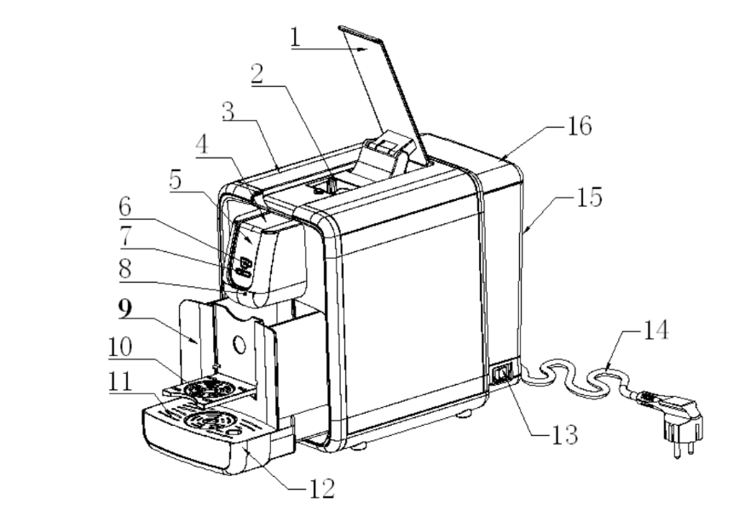
3. Body of the appliance
4. Decoration-circle
5. Standby button
6. Cup
7. Stop-light-block
8. Water softening filter
9. Capsule insertion box
10. Cup frame
11. Tray cover
12. Drip tray
13. Power switch of appliance
14. Power cord
15. Water tank
16. Tank cover

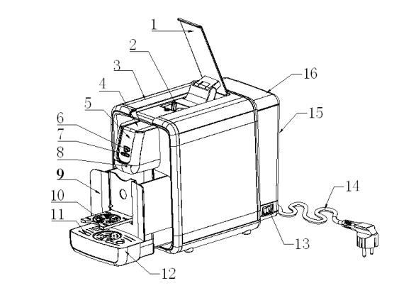

Figure 1

Warning
Read instructions carefully before using the new coffee machine for the first time. Keep in place where you can find and read for future reference.

- Check and make sure that the appliance and all accessories are working before removing packaging and using the appliance.
- The materials (plastic bags, expanded polystyrene) should be kept away from children because such materials can cause dangers.
- Make sure that electrical voltage is correct before connecting plug the in. The tag is located on the body of the motor.
- Always remove the plug from the wall socket before cleaning or maintenance of the appliance.

Non-compliance with the mention above could damage the safety of the appliance.

- Cutting off the mains cord after removing the plug from the wall socket, if you decide not to use this appliance anymore.
Parts of the appliance could be dangerous, especially for children who might use such parts of the appliance as toys.
- This appliance is suggested to be used in household such as kitchen areas, offices, farm houses, hotels, motels.

Appliance installation must be performed according to the instructions.
Incorrect installation could cause damage to person, animals, and the manufacturer cannot hold responsibility in case.
- To avoid the danger from overheating, unwind the electrical cord and use the appliance as recommended in precautions".
- Do not allow the power cord to pass around corners, over sharp edges, or over hot objects, and keep it away from oil.
- Do not plug the appliance and remove the plug from the mains outlet when you do not use it for extended time.
- Keep the appliance away from washbasins, taps or flames at least 60 cm.

This appliance is not appropriate for using by persons (including children) who lake sensory or mental capabilities, or lake experience and knowledge.

Ensure that children do not play with the appliance.

- When the appliance is connected to the power, never leave it unattended.
- Only connect the appliance to an earthed socket.
- Do not pull the cable of the appliance.
- Never immerse the appliance into water when cleaning.
- Surface of appliance will get hot during use.
- Always set the machine on stable and level surface.
- Place the coffee machine in a safe place where nobody can tilt it or be harmed by it.
- Do not use the coffee machine in outdoors.
- Do not place the appliance on hot surface or close to flames since it can cause damage to the appliance.
- Keep the water tank empty if the appliance is not used for a long time period.
- Avoid repairing the appliance by your own.
- If the appliance was repaired by an unauthority, your guarantee becomes invalid.

Filling the tank
Always unplug the appliance before filling the water into tank.
- Open the cover of tank (2) and fill cold water into the tank until the indicated maximum level (1000 ml), then close the cover.
- Connect the plug.

Only fill cold water into the water tank. Always use fresh water every time. Do not use sparkling mineral water or other fluids.
Always check that there is water in the tank since running the water pump with no water in the tank will cause pump to overheat.

Start/Warming up the coffee machine
- Fill the water into the tank until the indicted maximum level.
- Connect the plug to the power supply socket.
- Open the appliance by pressing the button (13, figure 1).
- When the temperature is appropriate, the flattening will light up constantly.

Maintenance
Daily Cleaning
- Do not insert any capsule, press the open button and wait for dispensing until finish. The water dispensed will be collected in the drain tray (12, figure 1).
- Empty the drain tray.

Cleaning the appliance

- Always unplug the appliance before cleaning.
- Do not immerse the body of the appliance in water.
- Never dry any part of the appliance in microwave ovens.
- Do not wash the appliance in dishwasher.

- Use wet cloth to clean the appliance, but do not use abrasive cleaner.
- Pull out the drip tray (7) and clean it with liquid dish washing.
- Empty the water from the tank (10, figure1). Clean it with fresh water and put it back.

De-scaling
The formation of lime scale is a natural effect when you use the appliance. The appliance should be de-scaled in every 5-6 months.
- Switch off the machine.
- Remove the tank and pour the water.
- Fill de-scaling solution following the instruction on the product package.
- Never insert any capsule, press the button and wait for finishing.
- Switch on the appliance.
- Leave the de-scaling solution about 10-15 minutes.
- Repeat procedure from point4 until the tank is empty and turn on the appliance.
- Remove the water tank, clean properly and fill it with fresh water.
- Turn on the appliance.
- Never insert any capsule, press the button to open the appliance and wait for dispensing to finish. Repeat this procedure until the tank is empty, and the water will be collected in the drip tray. (12, figure1)
- When the tank is empty, turn on the appliance.
- Fill the water into the tank again and repeat since procedure from point 12.
- When the second washing is finished, fill the water into the tank again. Then, the appliance are ready for use.

Trouble shooting guide
If you experience any trouble while using the coffee machine, please refer to the following the advice given.

Fault | Reason | Solution
The product is not working. | -Wall outlet is not functioning. | -Plug another device into the same outlet to confirm the outlet is working.
The coffee is not hot enough. | -The heating system is not working. | -Please waiting for the appropriated temperature  -Contact dealer.
The pump is not working. | -The water tank is empty.  -The pump is defective. | -Fill the water into the tank properly.  -Contact dealer.
Coffee tastes sour. | -After descaling, the machine was not clean properly. | - Washing through the machine system.

