Company Profile
Bodindecha (Sing Singhaseni) School
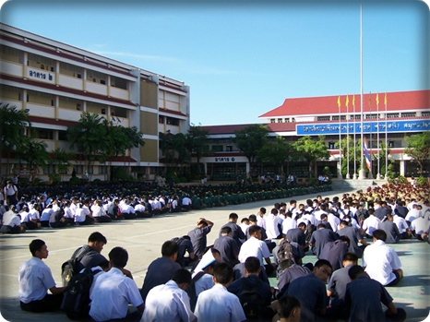
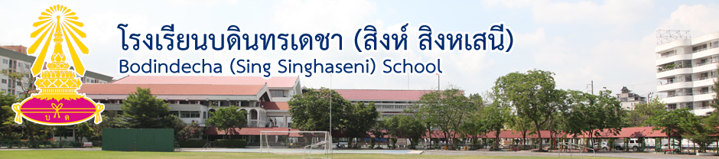

- School History
Bodindecha (Sing Singhaseni) School was formerly established on 30 April 1971. The land was occupied by Chao Praya Bodindecha (Sing Singhasewni), and Khun Ying Na Korn Rachaseni (Singhaseni) decided to donate the land to the Ministry of Education according to Chao Praya Bodindecha’s desire to have the place that can be useful for people. In 1964, Khun Ying Boonluen Kruatrachoo initially coordinated the establishment. The school provides good education and world class standard facilities that is the foundation for a bright future. Bodindecha has been permitted to use Phra Kiao as the school emblem since February 23, 1972. Chalerm Singhaseni was the first headmaster of the school. Initially, there were 838 students and 43 teachers in 1971.

School Overview
- Company Name
Bodindecha (sing singhaseni) School

- Established
April 30, 1971
- School Motto
Smart and well-behaved
- School Spirit
ChaoprayaBodindecha (Sing Singhaseni)
- School Emblem
PhraKiao, the Thai equivalent of the coronet that is worn by young princes and princesses.
- School Abbreviation
B.D.
- Founder
Khun Ying Boonluean Kruatrachue

Access to Bodindecha (sing singhaseni) School
Bodindecha (Sing Singhaseni) School
40 Soi Ramkhamhaeng 43/1, Phlabphla Sub-District, Wang Thonglang District
Bangkok 10310 Thailand
Telephone: 02 538 3964, 02 538 2573, 02 530 2747, 02 514 1403 Fax: 02 539 7091

- Vision
Organization’s purpose of Bodindecha (Sing Singhaseni) School is to encourage our students to develop themselves to have both excellent knowledge and good morals for success in the world community.

- Mission
The mission of Bodindecha (sing singhaseni) School is to provide students various education and develop management and efficiency in education according to good governance. Moreover, the school will help students in developing skills to become self-sufficient adults who will succeed in community.

- Motto
Smart and well-behaved

Philosophy
- To cultivate students’ academic and ethical excellence.
- Developing the quality of learners to reach the potential of the international standards with world class.
- To develop children of today into successful adults of tomorrow.

- Award Guaranteed School

- The King Royal Award for best school qualification was guaranteed by the Ministry of Education.
- School library awards was certified by the Ministry of Education and the Thai Library Association.
- Military Band of the school won 2002 World Championship For Marching Show Band certified By World Association of Marching Show Band Chiba Japan.

- Facilities
- A great library with various kinds of books, magazines, and newspapers.
- An outdoor basketball court.
- Large football field.
- 24-hour security with guards.
- Canteen serving tasty foods and desserts.
- Instructional computer labs with Internet access.
- Free Wi-Fi spots.
- Infirmary for first aid in school.

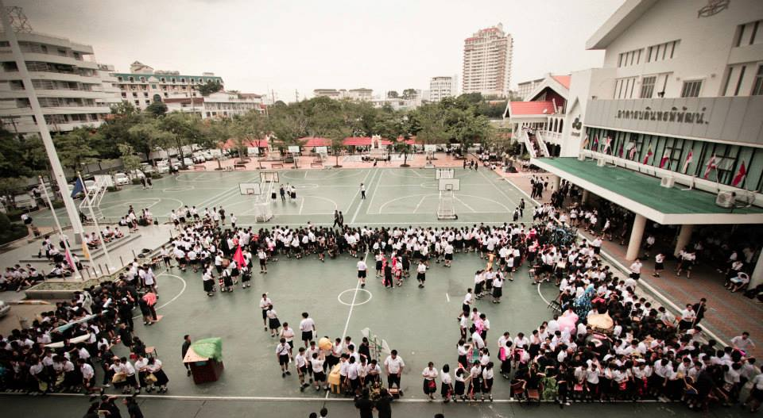

- Mission of Department

- Department of Thai Language
- To develop students’ skills to understand Thai language, and can apply it appropriately.
- Department of Mathematics
- The department has an aim to develop and enhance mathematics and quantitative reasoning skills.
- Department of Sciences
- To promote students’ scientiﬁc skills including planning, processing, problem solving.
- Department of Social Sciences (Sociology, religious, and culture)
- To develop students morally to be good citizens of Thailand.
- Department of Physical Education
- To promote the importance of health and develop the physical education.
- Department of IT & Technology
- To enhance students’ problem solving skills by using computers and instructional media.
- Department of Foreign Languages
- To develop witting, reading, listening, speaking, and critical thinking skills and encourage students to use these skills in daily lives.

