Phuket
FantaSea
The Ultimate Cultural Theme Park
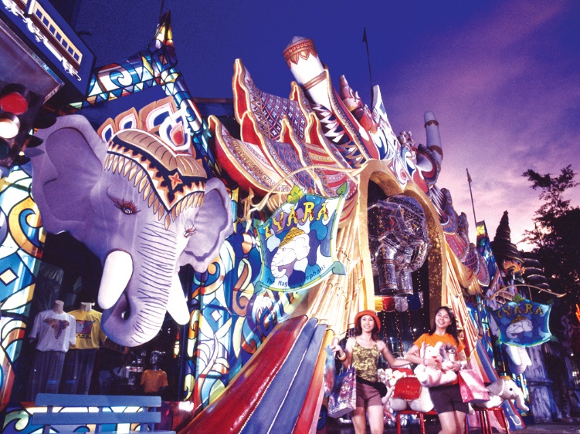
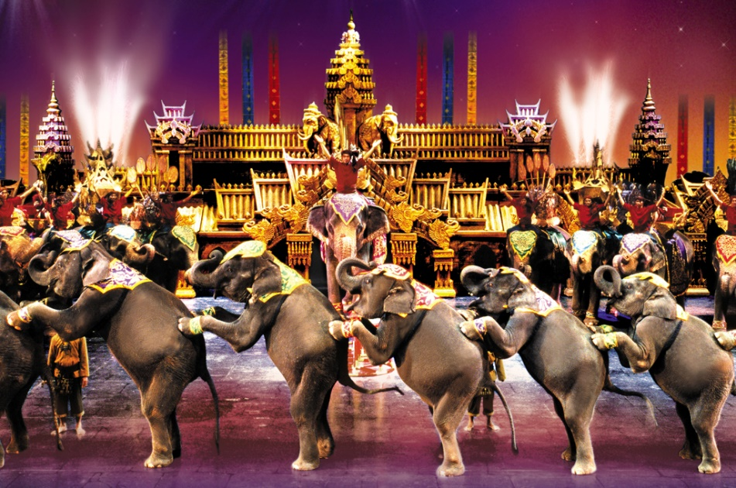
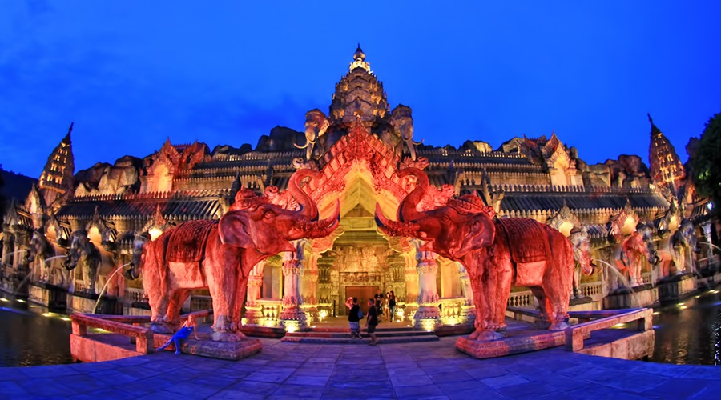

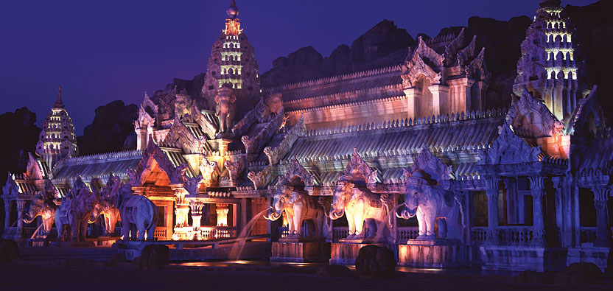
PHUKET
FANTASEA
THE ULTIMATE CULTURUAL THEME PARK

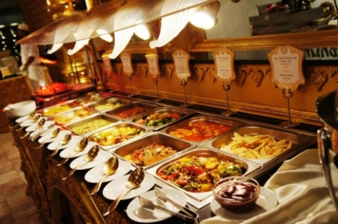
Golden Kinnaree
(Buffet Restaurant)
Golden Kinnaree is a buffet restaurant that has various Thai dishes and popular international cuisine including (Chinese, Japanese, European, Indian, Mexican, Korean and more). Specially, there are a special Muslim-only zone which has a daily Halal buffet line. Moreover, there are over 4,000 seats or 10,000 standing for visitors, and you will enjoy Kinnaree welcome dance and friendly atmosphere by friendly staff while you have dinner at our restaurant.

Suriyamas
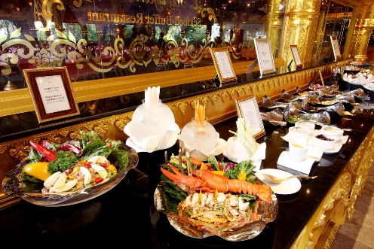
(Seafood Buffet Restaurant)
Suriyamas restaurant offers Thai and international Seafood cuisine over 50 dishes, excluding desserts and fresh fruits. Guests of Suriyamas can enjoy all the dishes in the connecting Golden Kinnaree Buffet Restaurant that offers over 70 dishes. Moreover, offering a tasty dining experience with food that made fresh daily and served in friendly atmosphere.

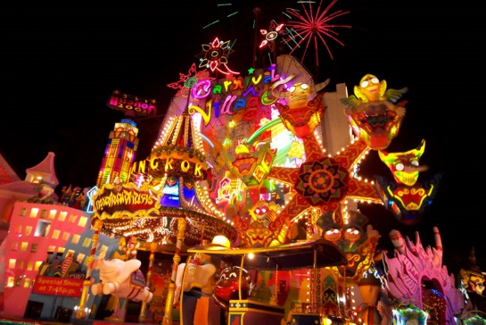
Festival Village
(Shopping Street)
Shopping street displays Thailand’s architectural history and traditional arts. There are 15 shops that offer silks, gifts, souvenirs, jewelry, items about elephants and much more. You will enjoy wonderful parades, street show, and elephant rides. There are beer garden that offers music and joy. Enjoy your shopping with us!

PHUKET
FANTASEA
THE ULTIMATE CULTURUAL THEME PARK

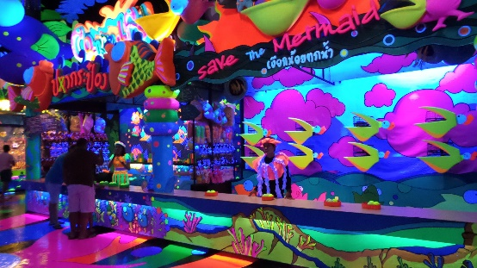
Similan
(Entertainment Center)
Similan Entertainment Center is undersea arcade and shopping attraction that has a lot of fun games for all ages. You will enjoy the theme of marine life in the Similan Island and exciting new games that can test your skill.

Fantasy of a Kingdom Show
(Cultural Illusion Show)
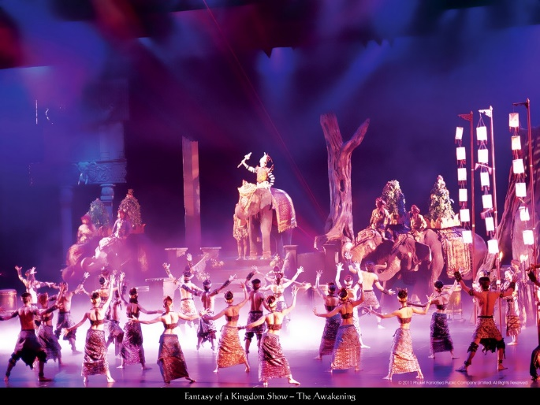
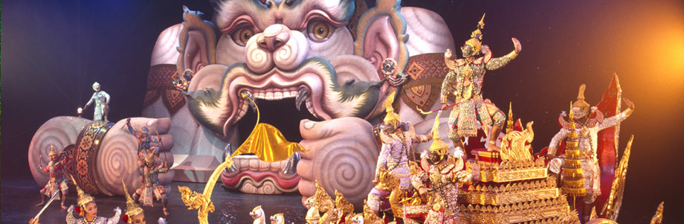
Fantasy of a Kingdom Show is a Thai cultural show mixed with illusion techniques and special effects. There are several shows that will delight visitors from around the world. Moreover, you will be surprised to see the animal performance, special effects, and magic illusion through 70 minutes.
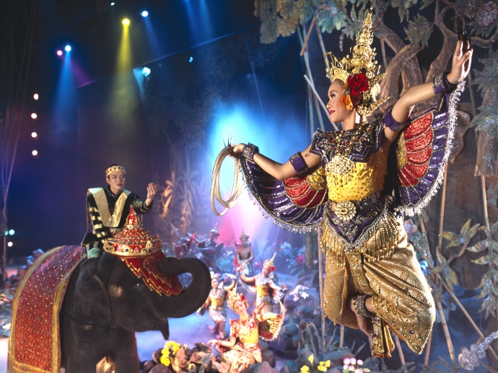
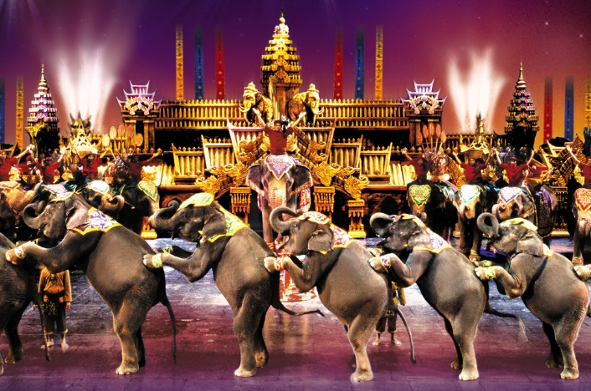

PHUKET
FANTASEA
THE ULTIMATE CULTURUAL THEME PARK

Ticketing & Prices
For Show with Buffet Dinner
- THB 2,200 per adult and THB 2,000 per child.

For Show Only
- THB 1,800 per adult and THB 1,800 per child.

(Children under 4 years old admitted free)

Directions & Map
For late reservation (after 12:00 hour on intended visit date)
Please call our reservation office directly.
Tel : +66 76 385 111, +66 76 680 888
Fax : +66 76 385 222, +66 76 680 889
Email : ticket@phuket-fantasea.com

